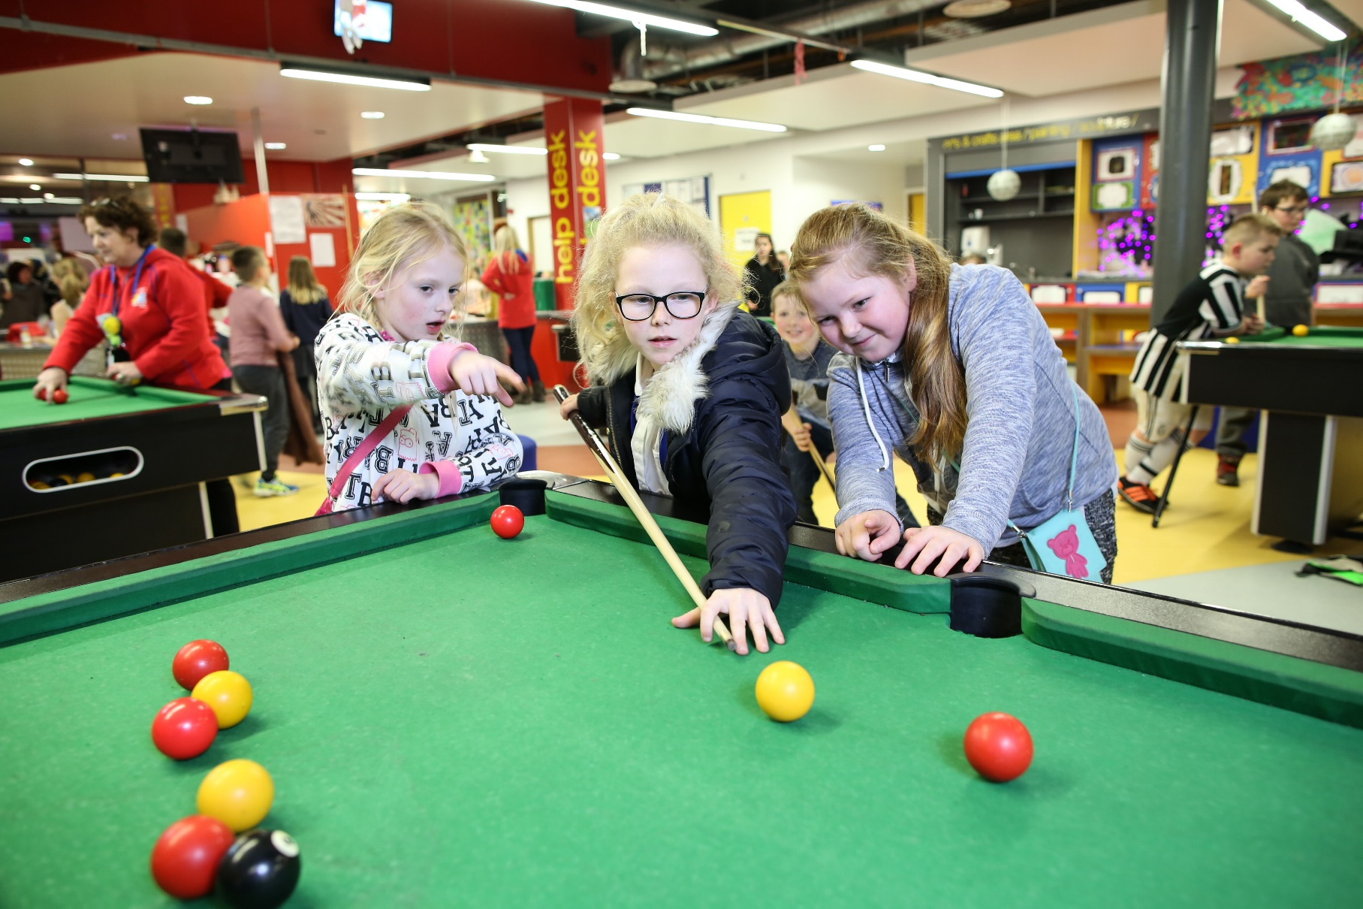

**Engagement & Activities Volunteer**

Our Volunteer Youth Workers are at the forefront of our sessions that run every day. They help to create a fun, safe, supportive environment where they engage with young people in a variety of different ways; meeting young people as they enter, showing new members around, spporting them and encouraging them to take part, think playing pool, hosting FIFA tournaments or just having a chat with a young person. In doing so, you will help to build their confidence, social skills and overall wellbeing.

**ABOUT THE ROLE**

**WE’RE LOOKING FOR SOMEONE WHO:**

**WHAT ARE THE BENEFITS TO YOU AND OUR YOUNG PEOPLE?**

**WHAT CAN YOU EXPECT TO BE DOING?**

**Location: Inspire Youth Zone  
Suggested Time Commitment: 4 hours p/week (although there is flexibility in this)**

You will gain new skills and develop existing ones whilst making a significant contribution to the lives of the young people. You will become part of our team and our young people will have a great time. You will enhance your CV whilst also being there as a positive role model to many of our young people. The benefits really are endless!

* Actively engaging with and spending time with young people
* Encouraging young people to participate and enjoy their sessions
* Building positive relationships with young people across the youth zone
* Working collaboratively with the session lead and other members of staff to support the delivery of sessions
* Supporting young people with additional needs
* Acting as a positive role model for young people
* Promoting an inclusive culture where all young people are listened to, valued, and cared for
* Creating a safe space for young people and working to safeguard them
* Enjoys meeting and engaging with people and encouraging young people to have fun
* Is adaptable and happy to try new things
* Is able to recognise the different needs of young people (based on their personalities) and is able to find ways to involve them
* Shares the same values of **Inspire**
* Is committed to making a positive impact on the lives of young people   
  ------------------------------------------------------------------------------------------------------------------------------------------------------

Please note that for this role you need to be at least 18 years of age and be prepared to undergo an enhanced DBS check.