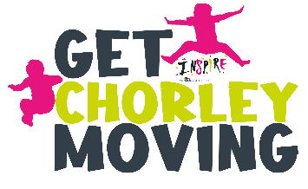
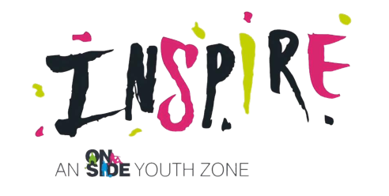
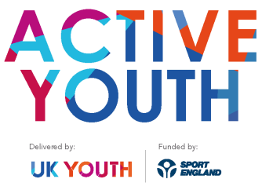

Participant Entry Survey

Welcome to GET CHORLEY MOVING! This survey is designed to help us get to know you. You will also be asked similar questions when you’ve finished the programme, so we can see if you think anything has changed. It’s not a test and there are no right or wrong answers. Your answers will be stored and analysed confidentially by UK Youth and the funder (Sport England, who are helping to support Get Chorley Moving) to evaluate the programme and will not be shared further.

Are you okay for your information to be used to study Active Youth? Yes ⃝ No ⃝

Your details

First name: | Last name:
Date of birth:
Name of youth club: Inspire, Chorley Youth Zone

- Why did you decide to take part in Get Chorley Moving (Active Youth)?

- In the past week, on how many days have you done a total of 30 minutes or more of physical activity, which was enough to raise your breathing rate?

This may include sport, exercise and brisk walking or cycling for recreation or to get to and from places. Please circle one option.

0 days | 1 day | 2 days | 3 days | 4 days | 5 days | 6 days | 7 days | Don’t know

Please continue to the next page...

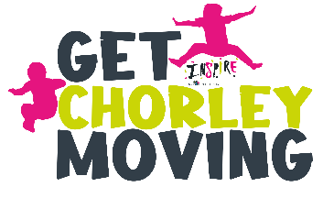
- How much do you agree with the following statements?

Please tick your answers.

 | Strongly disagree | Disagree | Can’t say | Agree | Strongly agree
If I find something difficult, I keep trying until I can do it
I enjoy taking part in exercise and physical activity
I feel confident when I take part in exercise and physical activity
I understand why exercise and physical activity are good for me
I know how to get involved and improve my skills in lots of different types of exercise and physical activity

- To what extent do you agree with the following statements?

This is on a scale of 0 – 10, where 0 is ‘I do not agree at all’ and 10 is ‘I completely agree’. Please tick your answers.

I don’t agree I completely at all agree
 | 0 | 1 | 2 | 3 | 4 | 5 | 6 | 7 | 8 | 9 | 1  0
I am able to motivate and influence other people

I feel confident at having a go at things that are new to me

I can do things as well as most other people

Thank you!

Please email this filled in form to: danny.coyle@inspireyouthzone.org

Signed by parent/guardian of participant………………………………………………………………………

Date / /2021

